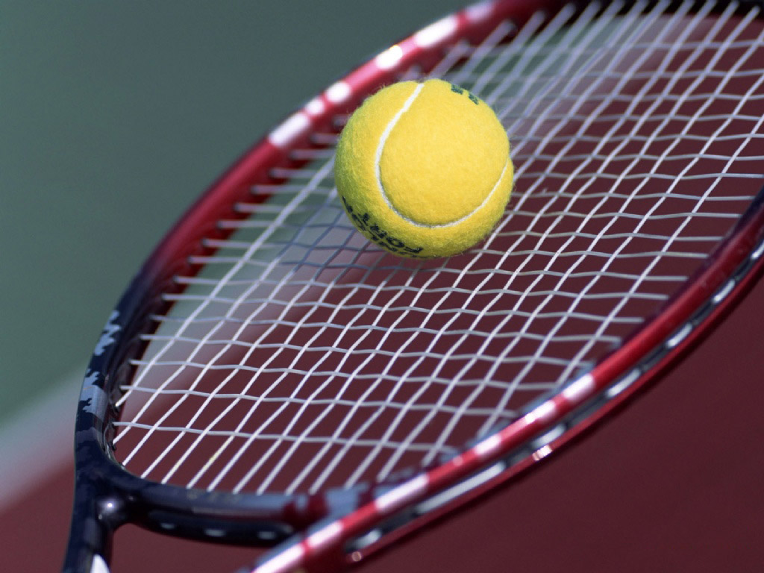

|  |  |  |  |  |  |  |  |  |  |  |  |  |  |  |  |  |  |  |  |  |  |  |  |  |  |  |  |  |  |  |  |  |  |  |  |  |  |  |  |  |  |  |  |  |  |  |  |  |  |  |  |  |  |  |  |  |  |  |  |  |  |  |  |  |  |  |  |  |  |  |  |  |  |  |  |  |  |  |  |  |  |  |  |  |  |  |  |  |  |  |  |  |  |  |  |  |  |  |  |  |  |  |  |  |  |  |  |  |  |  |  |  |  |  |  |  |  |  |  |  |  |  |  |  |  |  |  |  |  |  |  |  |  |  |  |  |  |  |  |  |  |  |  |  |  |  |  |  |  |  |  |  |  |  |  |  |  |  |  |  |  |  |  |  |  |  |  |  |  |  |  |  |  |  |
| --- | --- | --- | --- | --- | --- | --- | --- | --- | --- | --- | --- | --- | --- | --- | --- | --- | --- | --- | --- | --- | --- | --- | --- | --- | --- | --- | --- | --- | --- | --- | --- | --- | --- | --- | --- | --- | --- | --- | --- | --- | --- | --- | --- | --- | --- | --- | --- | --- | --- | --- | --- | --- | --- | --- | --- | --- | --- | --- | --- | --- | --- | --- | --- | --- | --- | --- | --- | --- | --- | --- | --- | --- | --- | --- | --- | --- | --- | --- | --- | --- | --- | --- | --- | --- | --- | --- | --- | --- | --- | --- | --- | --- | --- | --- | --- | --- | --- | --- | --- | --- | --- | --- | --- | --- | --- | --- | --- | --- | --- | --- | --- | --- | --- | --- | --- | --- | --- | --- | --- | --- | --- | --- | --- | --- | --- | --- | --- | --- | --- | --- | --- | --- | --- | --- | --- | --- | --- | --- | --- | --- | --- | --- | --- | --- | --- | --- | --- | --- | --- | --- | --- | --- | --- | --- | --- | --- | --- | --- | --- | --- | --- | --- | --- | --- | --- | --- | --- | --- | --- | --- | --- | --- | --- | --- |
| **Ficha de Inscrição**  **O GDC Fidelidade criou a Secção de Petanca que pretende ser uma outra ativiadade para os nossos associados.**  **O colega que irá orientar esta modalidade será o Victor Ferreira.**  **Nesta primeira fase a secção de Petanca irá centrar-se apenas na vertente lazer.**  **A Petanca tem a vantagem de não ser uma atividade cara e de se poder praticar em qualquer terreno plano, de preferência arenoso, e por qualquer pessoa. Homens ou mulheres, velhos ou novos, fortes ou fracos, todas as pessoas podem “atirar as bolas”. A Petanca não conhece nem sexo, nem idade, nem estatuto social.**  **Desporto simples, exercita, contudo, capacidades mentais e físicas que vão para além das exigidas num passatempo banal. Os praticantes desenvolvem concentração, habilidade, inteligência, paciência, estratégia e resistência muscular.**  **Aceite a nossa proposta, venha conhecer esta modalidade e desfrutar do prazer de praticar uma modalidade ao ar livre!** | | | | | | | | | | | | | | | | | | | | | | | | | | | | | | | | | | | | | | | | | | | | | | | | | | | | | | | | | | | | | | | | | | | | | | | | | | | | | | | | | | | | | | | | | | | | | | | | | | | | | | | | | | | | | | | | | | | | | | | | | | | | | | | | | | | | | | | | | | | | | | | | | | | | | | | | | | | | | | | | | | | | | | | | | | | | | | |
|  |  | |  | |  | |  | | | | |  | | |  | | | | |  | | |  | | |  | |  | | |  | | |  | | | |  | | | |  | | | |  | | | |  | | |  | |  | | |  | | |  | |  | | | |  | | | |  | | |  | | | |  | | | |  | | | |  | | | | |  | | | |  | | | | |  | | | |  | | | |  | | | | | |  | | | | |  | | | | | | | | | | | | | | | | |  | | | | | |  | | | |  | |  | | | | |  | | | |  | | | |  | | | | |  | | |  | |  | |  | |  | | | | |  | | | | |
| **Nome:** | | | | |  | |  | | | | | | | | | | | | | | | | | | | | | | | | | | | | | | | | | | | | | | | | | | | | | | | | | | | | | | | | | | | | | | | | | | | | | | | | | | | | | | | | | | | | | | | | | | | | | | | | | | | | | |  | | | | | | **Nº Sócio:** | | | | | | | | | | | | | | | | | | | | | | | |  | | | | | | | | | | | | | | |  | | | |  | | | | | | | | | |  | | | | | | | | | |  | | | | | | | | | | | | | | | | | | | | | | | | | | | | | | | | | | |
|  |  | |  | |  | |  | | | | |  | | |  | | |  | | | | |  | | |  | |  | | |  | | |  | | | |  | | | |  | | | |  | | | |  | | |  | |  | | |  | | |  | |  | | | |  | | | |  | | |  | | | |  | | | |  | | | |  | | | | |  | | | |  | | | | |  | | | |  | | | | |  | | | | |  | | | | |  | | | | | | | | | | | | | | | | |  | | | |  | | | | | |  | |  | | | | |  | | | |  | | | |  | | | | |  | | |  | |  | |  | |  | | | | |  | | | | | | | | | | | | | | | | | | | | | | | | | | | | | | | | |
| **Data de Nascimento:** | | | | | | | | | | | | | | | | | | | | | | | | | |  | |  | | |  | | |  | | | |  | | | |  | | | |  | | | |  | | |  | |  | | |  | | |  | |  | | | |  | | | |  | | |  | | | |  | | | |  | | | |  | | | | |  | | | |  | | | | | | | | | | | | | |  | | | | |  | | | | |  | | | | | | | | | | | | | | | | |  | | | |  | | | | | |  | |  | | | | |  | | | |  | | | |  | | | | |  | | |  | |  | |  | |  | | | | |  | | | | | | | | | | | | | | | | | | | | | | | | | | | | | | | | |
|  | | | | | | | | | |  | | | | | |  | | | | | |  | | | | |  | | |  | | | | |  | | | | |  | | | |  | | | |  | | | | | |  | | |  | |  | | | | |  | | | |  | | | | |  | | | | | |  | | | |  | | | |  | | | | | | |  | | | | |  | | | | | |  | | | | |  | | | | | | | |  | | | | |  | | |  | | | |  | | | |  | | | |  | | | | |  | | | |  | | |  | |  | | | | | | |  | | | |  | | | | | | | | | | | | | | | |  | | | |  | | | | |  | | |  | | | | |  | |  | |  | |  | |  | |  |  | |  | | |  |
| **Email:** | | | | | | | |  | | | | | | | | | | | | | | | | | | | | | | | | | | | | | | | | |  | | | |  | | | |  | | |  | | | | | | | | | |  | | | |  | | | | | | | | | |  | | | | | | | | | | | | |  | | |  | | | | | |  | | | | |  | | | |  | | | | |  | | | | | | | | | | | |  | | | |  | | | |  | | | | | | | | | | | | | | | | | | | | | | | | | | | | | |
|  | | | | | |  | | | | |  | | |  | | | | |  | |  | | | |  | | |  | | | |  | | | |  | | |  | |  | | | |  | | | |  | | |  | | | | | | | | | | | | | |  | | | |  | |  | | | | |  | | | |  | | | |  | | |  | | | | |  | | | |  | | | | |  | | | |  | | | | |  | | | | |  | | | | |  | | | |  | | |  | | |  | | | |  | | | | | |  | | | |  | | | | | | | | | |  | | | | | | | | |  | | |  | | |  | | | |  | |  | | | | |  | | |  | | |  | | |  | |  |  | |  | | | | | | | | | | | | | | | | | |
|  | |  | |  | | | | |  | | | |  | | | |  | | | | | | |  | | | | |  | | | |  | | | |  | | | | | |  | | | |  | | | |  | | | | |  | | | |  | | | | |  | | | |  | | | | | |  | | | | |  | | | |  | | | | | |  | | | | | |  | | | | |  | | | | | |  | | | | | |  | | | | | | |  | | | | | | |  | |  | | | |  | | | |  | | | | | | |  | | | | |  | |  | | | | | | | | |  | | | | |  | | | | | | | | | | | |  | | | | |  | | | |  | | |  | | | | |  | | |  | |  | |  | |  | |  | | |  | |  |  | |
| **Assinatura:** | | | | | | | | |  | | | | | | | | | | | | | | |  | | | | |  | | | |  | | | |  | | | | | |  | | | |  | | | |  | | | | |  | | | |  | | | | |  | | | |  | | | | | |  | | | | |  | | | |  | | | | | |  | | | **Contacto:** | | | | | | | | | | | | | | | | | | | | | | | |  | | | | |  | | | | | | | | | | | | | | | | | | | | | | | | | | | **Data:** | | | | | | |  | | | | | | | | | | | | | | | |  | | | | |

O GDC Fidelidade vai organizar um Torneio de Ténis de Campo, cuja final será no dia do seu aniversário, **24/05/14** (Sábado), na Região de Palmela.

Os dois primeiros classificados vão disputar a final. O terceiro e quarto disputarão o apuramento para o terceiro lugar.

Esta atividade é **gratuita** e **exclusiva** para todos os sócios.

As inscrições deverão ser enviadas até ao dia **28/04/14** (Segunda-feira) para o email: grupo.desportivo.reservas@fidelidade.pt